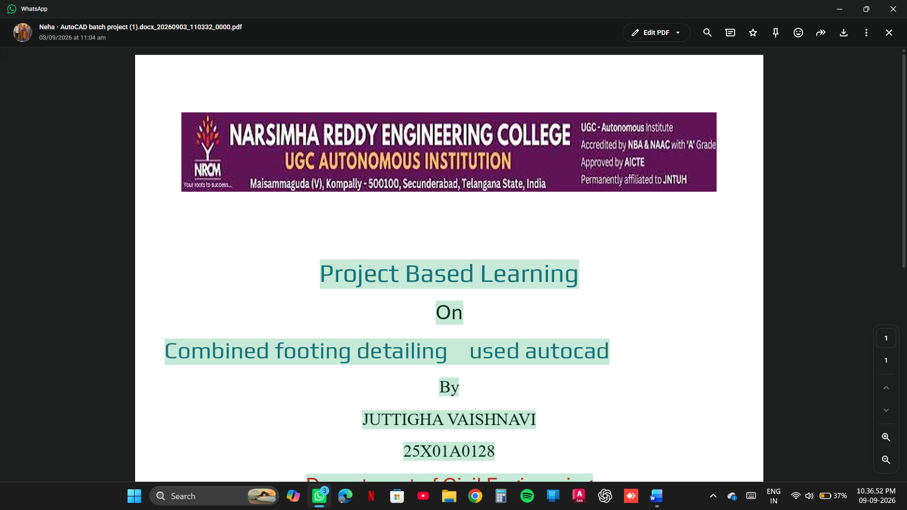
PROJECT BASED LEARNING
ON

COMBING FOOTING DESIGN AND DRAFTING BY USING AUTO CAD

BY

JUTTIGA VAISHNAVI 25X01A0128

DEPARTMENT OF CIVIL ENGINEERING

NARSIMHA REDDY ENGINEERING COLLEGE (UGC- AUTONOMOUS) APPROVED BY AICTE, AFFILIATED TO JNTUH, ACCREDITED BY NBA & NAAC WITH A-GRADE)
MAISAMMAGUDA (V), KOMPALLY, SECUNDERABAD,500100.(20262027)

COMPUTER AIDED DRAFTING SOFTWARE PROJECT

COMBING FOOTING DESIGN AND DRAFTING BY USING AUTOCAD

Project Report

ON

COMBING FOOTING

Civil Engineering – Computer Aided Drafting
Narsimha Reddy Engineering College (NRCM)

- Introduction
A combined footing is a type of shallow foundation that supports two or more columns on a single common base. It is generally provided when two columns are located close to each other or when one column is near the property boundary, making it difficult to provide separate isolated footings.
The main purpose of a combined footing is to distribute the structural loads safely and uniformly to the soil. It helps to prevent excessive settlement and provides stability to the structure.
In this project, the design and drafting of a combined footing are carried out using AutoCAD software. AutoCAD is a computer-aided design tool used to prepare accurate engineering drawings. It helps in creating the plan, sectional views, reinforcement details and dimensions of the combined footing.
This project provides practical knowledge of foundation design, structural detailing and computer-aided drafting.
- Problem Statement
In building construction, columns transfer loads from the superstructure to the foundation. When two columns are placed close to each other or near the property boundary, separate isolated footings may overlap or become unsuitable.
Therefore, a combined footing is required to support both columns safely and distribute their loads to the soil.
The main problem is to design a suitable combined footing with proper dimensions, reinforcement details and structural stability. Manual drafting may take more time and can lead to drawing errors.
To overcome these problems, AutoCAD is used to prepare accurate and detailed drawings of the combined footing.
- Objectives
The main objectives of this project are:
- To understand the concept and importance of combined footing.
- To study the structural behaviour of combined foundations.
- To design a combined footing based on column loads and soil bearing capacity.
- To determine the required length, width and depth of the footing.
- To calculate the reinforcement requirements for the footing.
- To prepare the plan and sectional views using AutoCAD.
- To show reinforcement details clearly in the drawing.
- To provide accurate dimensions and specifications.
- To improve knowledge of computer-aided drafting.
- To develop practical skills in civil engineering design and detailing.
- Proposed Methodology
The proposed methodology involves the following steps:
Step 1: Collection of Data
Collect the necessary design information, such as:
- Column loads.
- Column dimensions.
- Safe bearing capacity of soil.
- Grade of concrete.
- Grade of steel.
- Spacing between columns.
Step 2: Selection of Footing Type
Select a suitable combined footing based on column positions, loading conditions and site requirements.
Step 3: Design Calculations
Calculate the required footing area using the total column loads and safe bearing capacity of soil. Determine the footing dimensions and check the soil pressure distribution.
Step 4: Depth Calculation
Determine the required depth of the footing based on bending moment, shear force and punching shear considerations.
Step 5: Reinforcement Design
Calculate the required reinforcement steel and determine the spacing and diameter of reinforcement bars according to structural design requirements.
Step 6: AutoCAD Drafting
Prepare the engineering drawing using AutoCAD.
The following drawing details are included:
- Plan view of combined footing.
- Longitudinal sectional view.
- Cross-sectional view.
- Column positions.
- Reinforcement detailing.
- Dimensions and annotations.
Step 7: Final Drawing
Check the dimensions, reinforcement arrangement and drawing accuracy. Complete the final drawing with proper labelling and detailing.
- Results
The combined footing design and drafting were successfully carried out using AutoCAD.
The following results were obtained:
- A suitable combined footing layout was prepared.
- The required footing dimensions were determined through design calculations.
- Column positions were accurately represented in the drawing.
- Reinforcement details were prepared clearly.
- Plan and sectional views were developed using AutoCAD.
- Proper dimensions and annotations were added.
- A clear and accurate structural drawing was obtained.
The final drawing provides a detailed representation of the combined footing and its reinforcement arrangement.
- Outcomes
The project provides the following outcomes:
- Improved understanding of combined footing design.
- Knowledge of foundation design principles.
- Practical experience in calculating footing dimensions.
- Understanding of reinforcement detailing.
- Improved AutoCAD drafting skills.
- Ability to prepare plan and sectional views.
- Knowledge of structural drawing standards.
- Better understanding of load transfer from columns to soil.
- Improved accuracy in engineering drawings.
- Development of practical civil engineering skills.

TOP VIEW

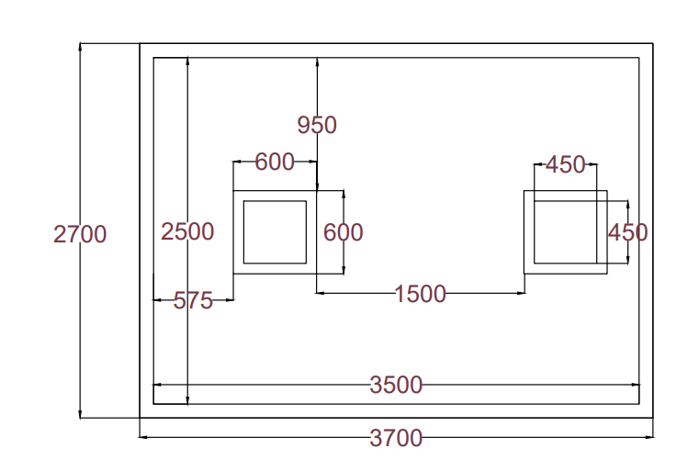

SIDE VIEW

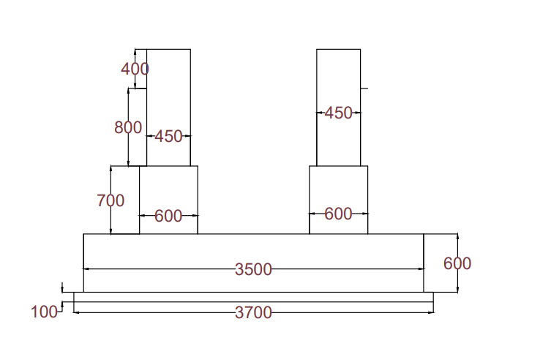

- Conclusion
The project "Combined Footing Design and Drafting Using AutoCAD" helps in understanding the design and detailing of combined foundations in building construction.
The combined footing provides a common foundation for two or more columns and helps distribute structural loads safely to the soil. Through this project, the footing dimensions, depth and reinforcement requirements are studied and determined using suitable design calculations.
AutoCAD is used to prepare accurate and clear engineering drawings, including plan views, sectional views and reinforcement details.
Finally, this project improves practical knowledge of foundation engineering, structural design and computer-aided drafting. It also provides valuable experience in applying theoretical civil engineering concepts to practical construction work.
- References
- B.C. Punmia – Soil Mechanics and Foundations, Laxmi Publications.
- S. Ramamrutham – Design of Reinforced Concrete Structures, Dhanpat Rai Publishing Company.
- N. Krishna Raju – Design of Reinforced Concrete Structures, CBS Publishers.
- IS 456:2000 – Plain and Reinforced Concrete – Code of Practice.
- IS 1904:2021 – General Requirements for Design and Construction of Foundations in Soils.
- IS 875 – Code of Practice for Design Loads (Other Than Earthquake) for Buildings and Structures.
- Autodesk – AutoCAD User Guide and Documentation.



